Streamixpro Application Examples

Field Example 1.1

Application area/industry: Oil and Gas; Enhanced oil Recovery
We consider a special method of secondary oil recovery (ie. requiring an injected fluid to push the oil toward a production well to obtain a high percentage of the oil originally in the reservoir) namely solvent based enhanced oil recovery (EOR).
Aim:-
To examine the efficiency of the process considering that the reservoir consists of thin layers of sedimentary rock: A typical two-layer portion of the reservoir cross section is here modelled.
Therefore:-
This is an example of a two-layered reservoir segment which is undergoing enhanced oil recovery by injection of a miscible solvent to displace the oil toward the production well. The solvent may be supercritical CO2 or enriched hydrocarbon gas. The way the solvent mixes with the oil is crucial to the efficiency, as no mixing would allow channelling of solvent along the higher permeability layer leading to premature breakthrough at the producer before oil from the less permeable layer can be released. Very rapid mixing ensuring near constant compositions over the cross section is an advantage while lower degrees of transverse mixing will extend composition profiles and reduce the efficiency of the oil recovery process.

The thickness of the two layer unit is chosen as 10cm with a length of 1000m, other factors are chosen as being within a commonly occurring range for this type of oil-recovery field process.
The table below gives the values of required parameters used in the EOR project: example:-

Table 1.1(a) Input Values
Section | Parameter | Value | Units
1 Flow Unit | Thickness of flow unit | 10 | cm
 | Length of flow unit | 1000 | m
 | Darcy flow velocity (Average) | .001 | cm/s
 | Transverse dispersion co-efficient | .00001 | cm2/s
2 Fluid Viscosities | Resident fluid viscosity | 1.0 | cP
 | Injected fluid viscosity | 0.5 | cP
3 Geology –Layer* Properties | Layer 1 porosity | 0.3 | fraction
 | Layer 2 porosity | 0.4 | fraction
 | Layer 1 permeability | 0.9 | darcies
 | Layer 2 permeability | 0.3 | darcies
*Layer “1” is uppermost

Gravity inclusion is selected or not by ticking the boxes in Section 4, then if required, the parameters which influence flow under gravity are entered within Sections 5 and 6. Here we choose “Yes” for gravity effects and the required factors are entered as on the table below:-

Table 1.1(b) Input Values
Section | Parameter | Value | Units
4 Gravity | Gravity option | Yes* | -
5 Geology –Miscellaneous | Angle of dip | 30 | deg
 | Transverse to longitudinal permeability ratio | 0.5 | -
6 Fluid Densities | Direction of fluid flow | Downward
 | Resident fluid density | 0.8 | g/cm3
 | Injected fluid density | 0.3 | g/cm3
*”Yes” gravity option then requires Sections 5 and 6 to be filled in otherwise they are skipped.

The input values chosen are discussed in more detail in the appendix. Once the input entries are checked we click “Calculate” and as we wish to show the main calculated parameters (so select Yes) and also the concentration vs pore volumes data (select Yes).

Output screenshot is a below:-

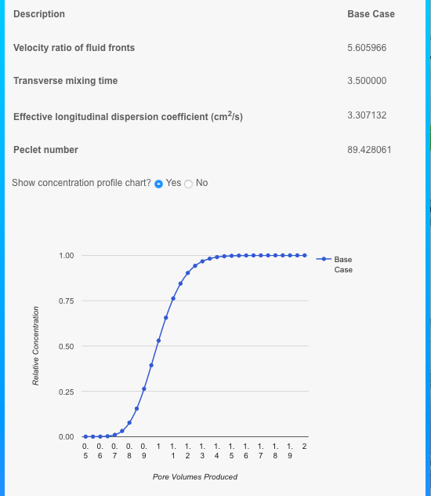

The factors calculated are the velocity ratio of fluid “fronts” which is 5.6 (representing a moderate case of preferential channelling along the higher permeability layer), transverse mixing time is 3.5 (>1 so transverse dispersion dominates), effective dispersion coefficient is large at 3.3 cm2/s, and the Peclet number is 89 representing a moderate length of mixing zone as shown on the plot.
The mixing zone covering 10%-90% concentration spans an interval of 0.38PV which would correspond approximately to a mixing zone length of 380m (within a total flow length of 1000m).
Breakthrough of for example a 10% concentration of injected fluid occurs after 0.82 PV or 332 days (at given injection rate).

Field Example 1.2
Application area/Industry: Oil and Gas; (Enhanced Oil Recovery)

Here we keep the same description as in Example 1.1 (above) but increase the flow rate by three-fold to 3x10⁻³ cm/s. Therefore all the input values are the same as in Tables 1.1(a) and (b) except for the “Darcy flow velocity” in Section 1.

The recalculation can replace the previous case using the “Edit” key or we can use the “Duplicate” function to create a new case alongside the first. Then the flow rate can be changed to the new value in Section 1 (Flow Unit), and all other previously set inputs can be accepted using the “Next” buttons.
Checking all our inputs we can label the new calculation (“point”) “High Flow Rate”.
Once these are checked we click “Calculate” to show the main calculated parameters (and also the concentration vs pore volumes data) alongside the base case results.

Output screenshot of the composition profiles is a below:-

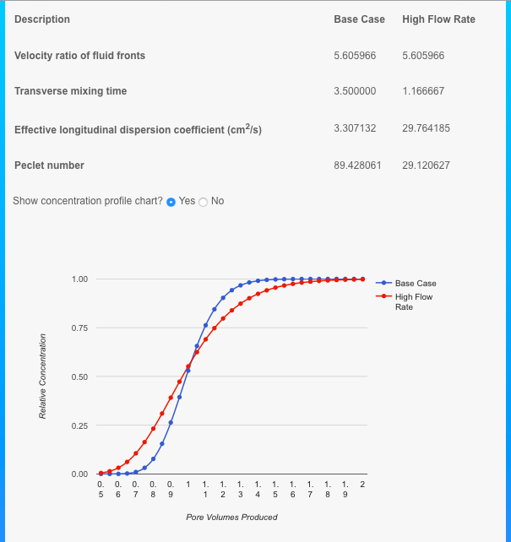

The transverse mixing time is shorter at 1.167 (compared with 3.5). As it is just >1 so transverse dispersion just dominates. The effective dispersion coefficient is increased to 29.8 cm2/s (compared with 3.3 cm²/s for the low rate base case), and the Peclet number is 29.1 resulting in a very long mixing zone as shown on the plot.
The reason that dispersion is greatly increased is due to less time for transverse mixing to occur (which would tend to dampen the channelling effect), this allows more channelling and a longer mixing zone to develop.

A short discussion of the implication of these results is given in the appendix.

Field Example 2.1

Application area/industry: Environmental
This is a water resources problem whereby high salinity sea water is encroaching on a fresh water aquifer. The rate at which the saline water progresses through the aquifer will determine the lifetime of drinking water quality at the wells.
The aim of the calculations:
The rate of channelling through the high permeability zone/s and the degree of mixing of the two waters are to be calculated. It is accepted that a two-layer flow section represents a typical structure within the aquifer. This will help to provide an estimate of the lifetime of production of acceptable water quality supply.

Here we examine the impact of layers of 50cm thickness over a total length of 1000m, which may correspond to spacing between coast and well.

The input values are summarized on the table below:-

Table 2.1(a) Input Values
Section | Parameter | Value | Units
1 Flow Unit | Thickness of flow unit | 50 | cm
 | Length of flow unit | 1000 | m
 | Darcy flow velocity (Average) | .0001 | cm/s
 | Transverse dispersion co-efficient | .000015 | cm2/s
2 Fluid Viscosities | Resident fluid viscosity | 1.0 | cP
 | Injected fluid viscosity | 3.6 | cP
3 Geology –Layer* Properties | Layer 1 porosity | 0.3 | fraction
 | Layer 2 porosity | 0.3 | fraction
 | Layer 1 permeability | 10.0 | darcies
 | Layer 2 permeability | 2.0 | darcies
*Layer 1 is uppermost

Gravity inclusion is selected by ticking the box in Section 4.

The table below shows the input values chosen for this example which is expected to be influenced by gravity effects induced by the large density contrast between the two waters.

Section | Parameter | Value | Units
4 Gravity | Gravity option | Yes | -
5 Geology –Miscellaneous | Angle of dip | 30 | deg
 | Transverse to longitudinal permeability ratio | 0.5 | -
6 Fluid Densities | Direction of fluid flow | Downward
 | Resident fluid density | 1.0 | g/cm3
 | Injected fluid density | 1.24 | g/cm3

A brief discussion of the input values is given in the appendix.

Once the input values are checked we click “Calculate” and as we wish to show the main calculated parameters (select Yes) and also the concentration vs pore volumes data (select Yes).
Output screenshot is a below:-

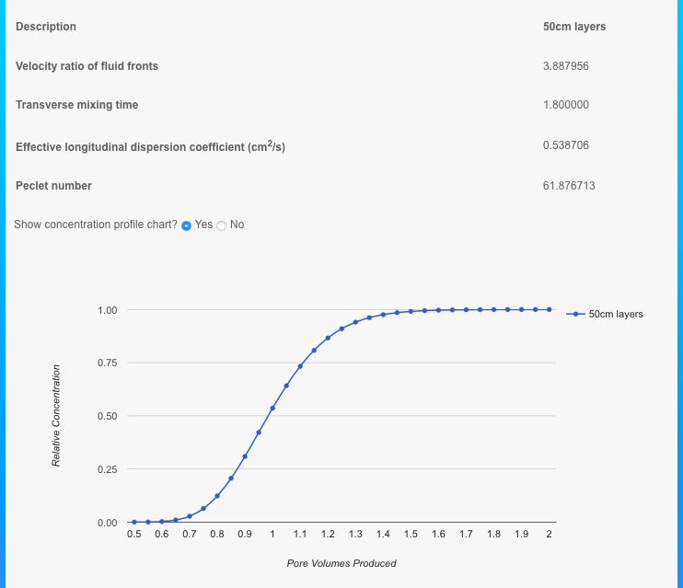

The factors calculated are the velocity ratio of fluid “fronts” ( 3.89 representing a mild case of channelling) transverse mixing time is 1.8 (>1 so transverse dispersion dominates) effective dispersion coefficient is 0.54 cm²/s , and the Peclet number is 61.9 representing a long length of mixing zone as shown on the plot.

Channelling is suppressed by the effect of the stabilising fluid mobility ratio (<1) so reducing the frontal velocity ratio to below that which would occur for equal viscosity fluids (given by the conductance ratio of 5 between the layers, ignoring gravity.

The 10% sea water breakthrough at the 1000m distant well would occur after just below 0.8 PV fluid flowed, or after about 7.5 years*.

Field Example 2.2 (Environmental)

Here we examine the impact of thinner layers of 15cm thickness over the same total length of 1000m and all other factors the same as in the above example (2.1). This should show the importance of the layering characteristics of the aquifer formation under consideration.
So here we can modify Section 1 of our base case to reflect the new estimate of layer thickness. By duplicating the previous case (50cm layers) and then editing to change the layer thickness and to name the case “15cm layers” we can compare the two sets of results directly on the resulting composition profiles as shown below -

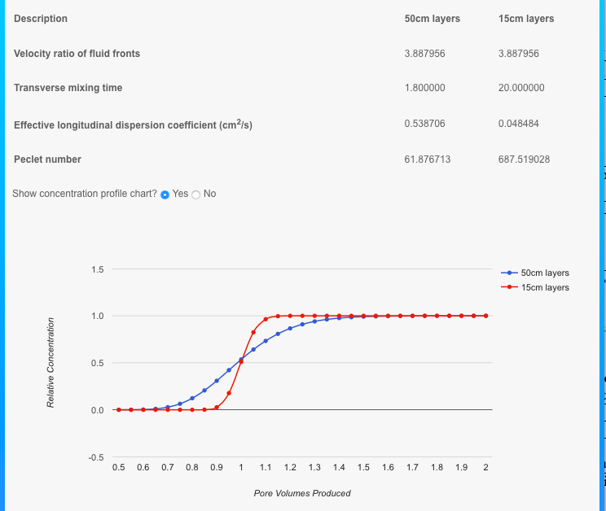

Far less dispersion results, due to much increased transverse mixing in the latest case. The mixing time is now increased to 20 resulting in a relatively low dispersion coefficient (0.05 cm²/s) and large Peclet number (688).
Breakthrough of the 10% concentration is now delayed to around 0.93 PV flowed or 8.85 years.

Appendix
Notes on example applications.

Example 1.1:
Commentary on the input parameters:-
Here we examine the impact of layers of 10cm thickness (below seismic and well log resolution but as measurable from core and perhaps outcrop data) over a total length of 1000m, which may correspond to interwell spacing in an offshore field. The flow rate (Darcy velocity or volume flow per unit cross sectional area) is 10⁻³ cm/s representing a value within the typical oilfield range. The transverse dispersion coefficient is here estimated based on the molecular diffusion coefficient 10⁻⁵ cm²/s which is often used as default value for liquid flows at the very low flow rates typical in oilfields and aquifers.
These inputs are made into Section 1: Flow Unit
Fluid Viscosities are entered in Section 2. These may represent an oil (1cP) being displaced by a solvent (0.5cP). The flud “mobility ratio” is therefore equal to 2.0.
Section 3 deals with layer porosities and permeabilities, and here we choose porosities of 0.3 and 0.4 and permeabilities of 0.9 darcy (900 mD) and 0.3 darcy (300 mD) for layers 1 and 2 respectively. Layer1 is here defined as the uppermost layer which has an impact if it is required to include gravity effects as below.
Sections 5 and 6 request the angle of dip of the geological layers (30 deg chosen) the ratio of transverse to longitudinal permeabilites covers anisotropy of the reservoir flow properties (generally <1 and here 0.5 is assumed), direction of flow (downward chosen as this process is designed to be gravity stable) and the density of the fluids (Resident fluid 0.8 g.cm3, Injected fluid 0.3 g/cm3 which may apply to an oil being displaced by a lighter solvent).

Example 1.2 is a variation on 1.1 with only the flow rate changed. For simplicity the transverse dispersion coefficient is assumed to remain constant, while it has been shown by laboratory tests that this parameter will increase with flow rate, however in this range the effect is expected to be minor.

Implications of the results: This is an illustration of the possible consequences of high rate solvent injection, in that long mixing zones could develop. This can mean that the efficiency of oil recovery could be threatened because it would take longer to establish high solvent concentrations at any point within the reservoir section being modelled. Also, if the solvent is injected as a limited volume slug the required critical concentrations to maintain miscibility may not be attainable. Slug concentration profiles can be obtained by subtraction of leading and trailing profiles, shifted along the produced volume (time) axis by the slug volume (in fractional PV units) as discussed in Wright and Dawe (2016).

Example 2.1

Notes on inputs:-
The flow rate (Darcy velocity or volume flow per unit cross sectional area) is 10⁻⁴ cm/s (10x slower than in the oil reservoir example 1.1). The transverse dispersion coefficient is here estimated based on the molecular diffusion coefficient 1.5x10⁻⁵ cm²/s based on molecular diffusion coefficient of strong NaCl solutions at moderate temperature.
These inputs are made into Section 1: Flow Unit

Fluid Viscosities are entered in Section 2. These represent fresh water (1cP) being displaced by an extreme case of a concentrated brine similar to Dead Sea water. (3.6cP). The fluid “mobility ratio” is therefore equal to 1/3.6.

Section 3 deals with layer porosities and permeabilities, and here we choose porosities of 0.3 and permeabilities of 10 darcy (layer 1) and 2 darcy (layer 2). Layer1 is here defined as the uppermost layer which has an impact as we include gravity effects as below.
Sections 5 and 6 request the angle of dip of the geological layers (30 deg chosen) the ratio of transverse to longitudinal permeabilites covers anisotropy of the reservoir flow properties (0.5 is assumed), direction of flow (downward chosen –ie from sea-bed down into water aquifer) and the density of the fluids (Resident fluid 1 g.cm3, Injected fluid 1.24 g/cm3 which reflects the high dissolved solids within the encroaching sea water).
Note on flow rates: It takes 9.5 years for 1PV to be injected/produced at Darcy rate of 10⁻⁴ cm/s or superficial flow rate of 3.33 10⁻⁴ cm/s ( 0.105 km/year) considering the effect of fractional porosity at 0.3.

Example 2.2 shows the important sensitivity to layer thickness as it affects the transverse mixing rate.

Brine properties are found in the references below:-

Viscosity and Density of the Dead Sea brines;
Weisbrod, N. et al. DOI:10.1016/j.hydrol.2015.11.036

NaCl diffusion coefficients:-
Lobo, V.M.M. (1993) Pure and Appl. Chem Vol 65, No12, pp2613-2640, IUPAC

www.aqion.de/site/194

